ORBliteration

Game Design Document

Prepared by:
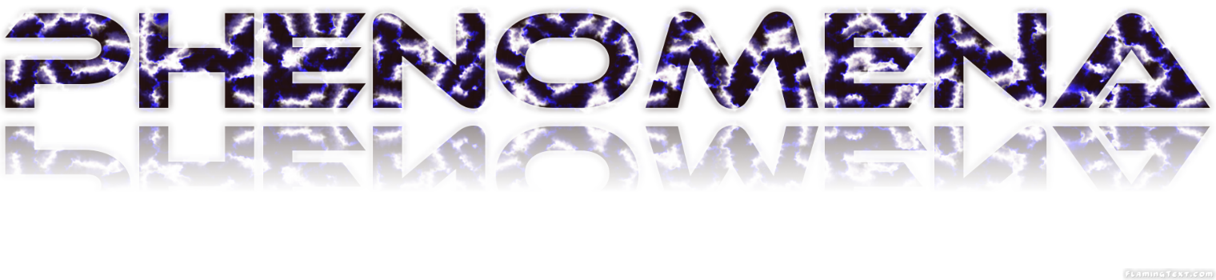Phenomena Studios

Contents
1. Revision Table 3
2. Game Overview 3
3. Gameplay 3
3.1. Mechanics 3
3.1.1. Movement 3
3.1.2 Combat 3
3.1.3 Power-ups 4
3.1.4 Arena Floor 4
3.2. Controls 4
3.3. Camera 4
3.4. End Condition 4
4. Game Design 5
4.1. Game Stages 5
4.1.1. Title Screen 5
4.1.2. Main Menu 5
4.1.3. Game Set Up 5
4.1.4. Loading Screen 5
4.1.5. Match Start 5
4.2. Multiplayer 5
4.3. User Interface 5
4.3.1. Menu 5
4.3.1.1 Main Menu 5
4.3.1.2. In-Game Options Menu 6
4.3.1.3. Game Setup Menu 6
4.3.2. In-Game HUD 6
4.3.3. Game Over Screen 6
4.4. Visual and Audio 7
4.4.1. Visual Style 7
4.4.2. Audio Style 7
4.4.3. Menu 7
4.4.3.1 Visual 7
4.4.3.2. Audio 7
4.4.3. Player Orbs 7
4.4.3.1. Visual 7
4.4.4. Power Ups 8
4.4.4.1. Visual 8
4.4.4.2. Audio 8
4.4.4.3. Ability 8
4.4.5. Surface Tiles 8
4.4.5.1. Visual 8
4.4.5.2. Audio 9
4.4.5.3. Tile Effects 9
4.4.6. Font 9
4.4.6.1. Visual 9
4.5. Assets 10
4.5.1. Asset Format 10
4.5.1.1. Naming Conventions 10
4.5.1.2. Texture File 10
4.5.1.3. Sound Files 10
4.5.1.4. Mesh Files 10
4.5.2. Assets List 10
4.5.2.1. 2D Assets 10
4.5.2.2. 3D Assets 11
4.5.2.3. Sound Assets 11
5. Summary 11

1. Revision Table

Revision Number | Date Changed | Change Description
1.0 | 04/08/2015 | Document Created

2. Game Overview
Control your battle Orb in a dynamic arena, fighting to be the last one left.
ORBliteration focuses on an action-packed environment, set in a stadium like arena where up to four players as Orbs battle it out until only one remains.
ORBliteration is set in a Tron-like setting, with dark backgrounds and vibrant neon lights to highlight important areas.

3. Gameplay
The game has each players being in their respective corners within the arena. After the countdown, players have full control of their Orbs and battle it out. Players move their Orbs to collect power ups, dodge the opponents or ram the opponents out of the arena.
Players are encouraged to be aggressive, seek out their opposition and actively push them out.
If aggression is not your style then you can seek a more survival orientated strategy where the player avoids the other Orbs, focuses on outlasting them and let them form their own demise. However due to the nature of the shrinking arena platform, players are forced into closer proximity as the match progresses.
The victor is the last Orb left in the arena.

3.1. Mechanics

3.1.1. Movement
The movement mechanic in ORBliteration takes input from the player and applies a direction to the Orb. The longer the same direction is held down, the faster the Orb will move in that direction until it reaches a maximum speed. This makes the Orb harder to control as it follows drift mechanics by sliding around when altering the current direction of the Orb. A slower speed allows the player more control as the changes in direction can be applied quicker than if a player is going at a higher speed.
The movement will have a smooth curve like transition between directions rather than an immediate direction change.

3.1.2 Combat
The main combat aspect in this game is to knock into your opponent, altering their current speed and direction. The faster an Orb is moving, the larger the force it will impact on another Orb. This alters their speed and direction pushing them in away from you.
The aim of the combat is to push your opponents off the arena while staying within the arena yourself.

3.1.3 Power-ups
Power-ups can be picked up by any player that comes in contact with it. The effect will be applied immediately. They can both benefit the player or not depending on which one was picked up, and the situation the player is currently in.
Power-ups are both spawned and placed randomly. The amount is capped based on the number of players in the match.

3.1.4 Arena Floor
The arena floor will be made up of smaller individual square tiles that change as the game progresses. The floor starts out as a big square platform that will slowly shrink over time. This is done by cracking the tiles (warning the player) on the outer perimeter. The tile is then removed completely after a small amount of time.
At the beginning of a game the arena floor is generated so that each tile holds its own properties. Rough and slippery tiles will have a small chance of being generated so that the majority of the arena is neutral. These differences in properties will be highlighted by coloring the tile with its respective color to indicate to the player that the tile is different.
- Neutral
  - No modifiers of Orbs movement.
- Rough
  - A coarser surface to create a greater friction causing Orbs that cross to lose speed and momentum. Denoted with red coloring.
- Slippery
  - A smooth slippery surface to create less friction and cause Orbs to slip quickly across the surface with less control. Denoted with blue coloring.

3.2. Controls
The player movement is the only game play and it is implemented with the left joystick of the Xbox 360 Controller.
Menu screens within the game will be navigated using the left joystick and the A button of the controller to confirm selection.

3.3. Camera
Bird’s eye view camera in a fixed position.

3.4. End Condition
The match is over when there is only one Orb (or none) left in the arena. A draw can only happen if all players left in the arena fall at the same time.
Matches will be a maximum of 90 seconds long which is enforced by the shrinking of the arena. The arena is only big enough to fit one perfectly balancing Orb at the end of the 90th second.

4. Game Design

4.1. Game Stages

4.1.1. Title Screen
ORBliteration – In big bold dual colored bright neon. Underneath that the words “Press any button to start” will be flashing.

4.1.2. Main Menu
Once player one has pressed any button the title will move to the top of screen and the main menu will appear.

4.1.3. Game Set Up
Once “Start Game” is selected the Game Set-up menu will appear where player one can select the number of players.

4.1.4. Loading Screen
When all players are ready the game will then start to load, bringing up the loading screen. The loading screen will not disappear automatically instead it will wait for any player to press any button once it has completed loading the game. In the bottom right hand corner the words “Loading…” will be flashing while game is loading. Once the game has loaded the words will change to “Press any button to continue”.

4.1.5. Match Start
A typical match will start with each player being placed in their respective corners of the platform, though not too close to the edges. Each players Orb will be a different color to indicate which player is controlling which Orb. In the corners of the screen will display the player number in their respective colors.
A count down timer from three will start and upon completion the round will start. Each player will then proceed to try and eliminate the others.

4.2. Multiplayer
The Game will not have a single player mode, instead the entire game will be multiplayer with two to four players playing on a local machine. This however will not be spilt screened, instead all players will be viewing the same screen. Once a player has lost, they will no longer be able to actively participate in the match instead will have to wait until the next round.

4.3. User Interface

4.3.1. Menu
The menu will be only controlled by the player one controller.

4.3.1.1 Main Menu
The main menu will go hand in hand with the overall theme/aesthetic of the game itself. The game title is at the top center and the menu items are depicted below also centered. The menu item will change in color to indicating it as the current selection.
- Main Menu Items:
  - Start Game – Takes player to the game set-up Screen
  - Options – Brings up Option menu
    - Full Screen On/Off – Toggles Full screen mode
    - Sound On/Off – Toggle the sound on or off
  - Instructions
    - Controls – Show the players the controls
    - Power Ups – Show players the effect of power ups
  - Exit – Closes The game

4.3.1.2. In-Game Options Menu
Once the game is paused by either player the screen should fade out of game play, though not completely, allowing players to still view the current game state. At which point the pause menu should be displayed. Control of the pause menu will be held by the player that pressed the pause key.
- Pause Menu Items:
  - Resume Game – Resumes game play
  - Options – Brings up Option menu
    - Full Screen On/Off – Toggles Full screen mode
    - Sound On/Off – Toggle the sound on or off
  - Instructions – Brings up instructions menu
    - Controls – Show the players the controls
    - Power Ups – Show players the effect of power ups
  - Exit – Returns player back to the main menu

4.3.1.3. Game Setup Menu
Once a player has decided to start the game they will be taken to the game set up screen. Within the set-up menu the player will decide on:
- Number of Player – Two to Four players

4.3.2. In-Game HUD
The In-game HUD will be minimalistic and non-diegetic. Being created on a HUD layer by itself and not part of the game world. The HUD will contain each player’s text (“Player 1”, “Player 2”, Etc.) in the corners of the screen. The font colors will be the same color as the players Orbs. In the top center will be a countdown timer which is synced with the decaying of the platform.

4.3.3. Game Over Screen
Once the end condition has been met (when there is only one or less players left on the platform). The Game Over screen will pop up, showing the list of players in order of rank (Rank is based on who was on the platform for the longest time). In the event of a draw both players will be given the same Rank. The player/s with the highest rank will be highlighted in the way of larger text while the rest of the players will be in a smaller text.

4.4. Visual and Audio

4.4.1. Visual Style
ORBliteration takes a lot of inspiration from Tron and will be using very similar visual effects. Using vibrant neon colors to highlight the important areas and components of the game, contrasting them onto a darker plain background.
Insert image (TRON LOGO)

4.4.2. Audio Style
The music genres are Dubstep, like Tron Legacy - Skrillex First of the Year and Trance / Techno, like Hard Trance Techno – Eternal. The game will have deep bass drops at crucial events in the battle arena.
The sound effects are glass, metal and electricity.

4.4.3. Menu

4.4.3.1 Visual
The visual style of the menu systems will go hand in hand with the overall aesthetic of Tron.

4.4.3.2. Audio
Navigating the menu will play metal clicking sound effect when switching between options and a power surge sound effect when an option is selected.
Playing in the background of the menu scene is Dubstep music to help accentuate the theme.

4.4.3. Player Orbs

4.4.3.1. Visual
The Visual style of each player will be a neon colored Orb with a black pattern over the top.
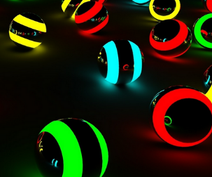
- Four Neon colored textures.
  - Red
  - Green
  - Yellow
  - Cyan
http://hdwalldes.com/neon-wallpaper/wallpapers-hd-neon-ball-wallpaper/

4.4.3.2. Audio
When the player moves around the platform and collides with other players, sound effects will accompany the player’s actions as they play through game.
- Movement on tile
  - Neutral: Rolling ball sound effect that changes the pitch based on the players speed
  - Rough: Squishing sound effect
  - Sliding: Sliding sound effect
- On collision
  - Metal hit sound effect

4.4.4. Power Ups

4.4.4.1. Visual

Visual style of each power up will be shown with different tile textures for each power-up. Each power-up colored with an orange outline.
- Speed Increase

  - Tile overlaid with basic Three arrow (Corporal)
- Confusion
  - Tile overlaid with basic whirlpool

- Size Increase
  - Tile overlaid with basic small ball and large ball

4.4.4.2. Audio
When a power-up is collected a sound will play indicating that is has been collected. It will also have a sound effect played while the ability of the power-up is in use.
- Speed Increase
  - On pickup – Lightning sound effect.
  - In use – The sound effect will be static / spark noise
- Confusion
  - On pickup – Lightning sound effect.
  - In use – The sound effect will be static / spark noise
- Size Increase
  - On pickup – Lightning sound effect.
  - In use – The sound effect will be static / spark noise

4.4.4.3. Ability
When a power is collected it will augment the player in some way. The use of the power up will be instantaneous.
- Speed Increase
  - The Orb’s current and max speed is doubled and lasts 6 seconds.
- Confusion
  - The current controls are randomly remapped and last 6 seconds.
- Size Increase
  - The orb doubles in size increasing total mass – therefore the rate of

4.4.5. Surface Tiles

4.4.5.1. Visual
The Visual style of the platform will be tiles laid out like a flat plane in a squared formation. Each tile will be color filled with a white border. The Color will be dependent on the type of tile.
- Neutral Tile
  - Black fill with a white border.
- Cracked Tile
  - Cracked filling with the accompanied tiles border.
- Rough Tile
  - Red fill with white border.
- Slippery Tile
  - Blue fill with white border.

4.4.5.2. Audio
To help with the theme of the game background techno music will play as the player’s battle it out. Trance background will play during the game over screen.
Audio cues will play when the tiles at the perimeter of the platform start to crack and another when the shatter and fall.
- Background
  - Techno
  - Trance
- On cracked
  - Glass cracking sound effect
- On shatter
  - Glass shatter sound effect

4.4.5.3. Tile Effects
Different Tiles will have different effects on the player’s movement across them.
- Neutral and Cracked Tile
  - No effect
- Rough Tile
  - Players moving on this tile will instantly slow down and any continued movement is reduced by half.
- Slippery Tile
  - Players moving on this tile will continue in the direction they were facing with the inability to move in any other direction until they clear that tile. The players speed is also doubled while on that tile.

4.4.6. Font

4.4.6.1. Visual
All text in the game will be using a Tron like font. The Font will have multiple colors to differ the type of text. All debug text will use “Arial” custom font.
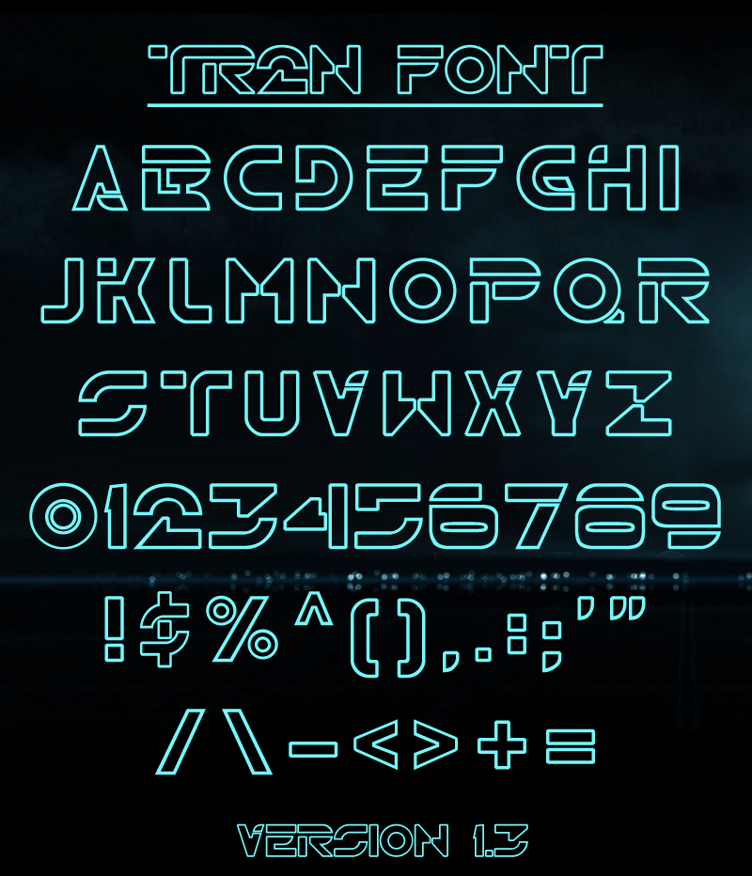
http://www.dafont.com/img/illustration/t/r/tr2n.png

4.5. Assets

4.5.1. Asset Format

4.5.1.1. Naming Conventions
The naming conventions for all external assets files should follow the following rule set.
- Custom font will be named in the format of “theme_Font_type.ttf”
- Textures will be named in the format of “theme_Texture_name.png”
- 3D assets will be named in the format of “theme_3DMesh_name.dat”
- Sound effect files will be named in the format of “theme_SoundFX_name.mp3”
- Music files will be named in the format of “theme_Music_name.mp3”
Where the ‘theme’ and ‘type’ can be renamed. Type is used to sort between bold, normal, italics and colors.

4.5.1.2. Texture File
Texture files should abide by the following
- Dimensions 1920 x 1200 as they fit the screen resolution size of the current MDS computers
- Use the .PNG file format due to the ability to compress without significant loss of data and has an alpha channel.

4.5.1.3. Sound Files
Sound files should abide by the following
- Use the .MP3 file format with a minimum bitrate quality of 320kbps.

4.5.1.4. Mesh Files
Mesh files should abide by the following
- Polygon count should be between 250 and 3000 to help optimize the overall game.
- Use the .DAT file format. DirectX 10 and above have the .X files deprecated.

4.5.2. Assets List

4.5.2.1. 2D Assets
- Background Skybox
- Square tile textures
  - Neutral
  - Cracked
  - Rough
  - Slippery
- Power-up textures
  - Speed Increase
  - Confusion
  - Size Increase
- Custom Fonts
  - Style
    - Arial
  - Color
    - Red
    - Cyan
    - Green
    - White
    - Yellow

4.5.2.2. 3D Assets
- Orb
- Platform Cube

4.5.2.3. Sound Assets
- Sound Effects
  - Metal hit
  - Rolling ball
  - Sliding
  - Squishing
  - Lightning
  - Spark
  - Static
  - Cracking glass
  - Shattered glass
  - Power surge
  - Victory - Cheering
  - Death/ Falling – Splash
- Music
  - Trance
  - Dubstep
  - Techno

5. Summary
Something goes in here

